

**ZIMBABWE ASSOCIATION OF BOREHOLE SURVEYORS**

“THE LAST ROD”

NEWSLETTER

**ZIMBABWE ASSOCIATION OF BOREHOLE SURVEYORS**

[www.zimbabweboreholesurveyors.co.zw](http://www.zimbabweboreholesurveyors.co.zw); Zimbabweboreholesurveyors.org.zw

**Zimbabwe Association of Borehole Surveyors Newsletter April, 2023**

**Editor’s notes**

In This Issue

* Editor’s notes
* Chairman’s Remarks
* Feature
* Our ecological footprint
* Get Kids into survey
* Surveyor of the month

**Dear readers,** it is with a special sense of pride and achievement that I welcome you to share in the first edition of our The Last Rod newsletter in this special 6 months after the landmark launch of our Association in Masvingo on 22 October 2022. Its humbling and inspiring to note that what started the Biblical fit size cloud of the Prophet Elijah is gradually developing into a terrible storm. The edition coincides with the start of the Hydrological Year which runs from 1st April to 31st March. We have therefore decided to adopt it as our Surveyors year.



Eric Tamuka

Let me hasten to introduce our MONIKER “The Last Rod”. The essence of this moniker is to make this newsletter engaging, fun as well as invoke some indelible painful or euphoric moments in the life of every Surveyor. Any Surveyor worth his or her salt will relive the anxiety, pressures, discomfort, hope and off course the excitement associated with this last rod. Undeniably, the last rod is both the magical or rod of fate for every Surveyor! In the next editions we hope to generate a lot of fun as we get live examples of such experiences.

If I may continue from where I left. The peculiar task we have in front of us at this juncture is, on the one hand, how to appropriately celebrate achieving the enviable milestone so far, and on the other, how to harness the wisdom and lessons of months-gone to continue the evolution of our noble vocation.

The wisdom of the Association’s founders in creating a structure through which Surveyors could order and regulate themselves has endured the tests of time, and has created a space for fellowship and growth as surveyors’ work underpinned every stage of our development as a nation. Largely unheralded, Surveyors have given yeoman's service to countless people and causes throughout the decades; this year we should give special effort to turning our proverbial faces forward and sharing our talents with the world. We must simultaneously guard against the lethargy that could easily accompany our vintage. Our rock-solid principles must now coexist in a world of rapid technological and social change.

The governance, ethics, practices, training, and education of Surveyors are competing with expectations of immediate gratification and shortened attention spans; how do we find the agility to be responsive without bending ourselves out of shape? With the frenetic advance of a new digital age of surveying in the form of advanced algorithms, artificial intelligence (AI), and ‘deep learning’, it is, paradoxically, the strict adherence to the foundational principles of organization, structure and discipline that will allow us to reap the greatest benefits from these changes, while also protecting ourselves and the public from the many known and unknown challenges that will accompany them. Congratulations to all who have shared in our brief history; and for those who are here for the future, let’s strap in and make the best of the opportunities ahead. Happy new year Zimbabwe Borehole Surveyors!

*Eric Tamuka Newsletter editor*

**The Chairman’s Tablet**

Dear Colleagues, as our Association enters its 6th month of existence, as members, we must take the opportunity to celebrate the rich history of our profession. The vision of our founding members, still holds true despite it being in its infancy. They taught us that [thinking is hard work; that’s why so few do it.](https://quotefancy.com/quote/763409/Albert-Einstein-Thinking-is-hard-work-that-s-why-so-few-do-it) These [great spirits have always encountered violent opposition from mediocre minds.](https://quotefancy.com/quote/991/Albert-Einstein-Great-spirits-have-always-encountered-violent-opposition-from-mediocre) They passed on to us that [failure is success in progress.](https://quotefancy.com/quote/763156/Albert-Einstein-Failure-is-success-in-progress)

Our Association is charged with supporting and protecting the character, status and interests of the profession of Borehole Surveying generally, and particularly of Borehole Surveyors practicing in Zimbabwe. We have seen in recent times where our profession

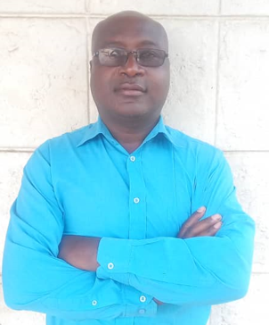

Eng. Jeskia Chigerwe

has faced criticism regarding the integrity of its professionals and how we manage our own affairs. Though these attacks may be unfounded and unwarranted, it is a stark reminder of the need of our Association to proactively defend the reputation of our profession, while also ensuring that our internal regulation is of the highest standards. The promotion of honourable practice and the repression of malpractice must be placed high on our agenda as an Association. Our duty to protect the profession and the public from those who operate outside of governing laws, as well as the codes of ethics to which we adhere remains a priority.

As we enter our maiden year, we will increase our efforts in rooting out and bringing to book those among our ranks who run afoul of our expected standards of operation. We also continue to commit to facilitating our members in settling disputed points of practice and matters of professional courtesy within our ranks. We must continue to identify where there is the need for our expertise and not shy away from making our collective voices heard.

Our contribution must be felt in the putting forth of new ideas, but we must also be strident in the defense of our existing practices and methods that have served us well in the past and preserve those that would reap no tangible benefit from wholesale change. As an Association it is incumbent on us to encourage the study of Borehole Surveying. This has always been a core tenet of our Association however it is now even more pressing as we observe a decline in the number of new entrants to the study of Borehole surveying. As an association we must seek to attract new entrants, support those who study to become Surveyors, play our part in the preparation of candidates for professional qualification while always encouraging and providing paths to continued professional development and career-long education for our members.

As we celebrate this significant watershed as an Association, our recognition of surveying’s importance and contribution to national development must be highlighted in an effort to advance and promote awareness of our profession generally. Our Association will also continue to keep its members in the know as we see the advancement of surveying methods and technology. In conclusion therefore colleagues, the core objectives set out at the creation of our Association still hold true today. Our association has the enviable position of a long and eventful future, providing lessons and experiences that can guide our way forward. The world is changed by your example, not by your opinion. [Information is not knowledge; the only source of knowledge is experience we need experience in order to gain wisdom.](https://quotefancy.com/quote/763745/Albert-Einstein-Information-is-not-knowledge-The-only-source-of-knowledge-is-experience) It is therefore our duty to impart this knowledge to the younger generation since they are the agencies for future propagation. In all our endeavors and practices let us act as responsible citizen and safe guard our environment and natural habitats. Let us therefore step into our inaugural year with a renewed sense of determination and enthusiasm for the advancement of our profession and Association

*Engineer Jeskia Chigerwe, Chairman*

**Evolution of Groundwater Technology**

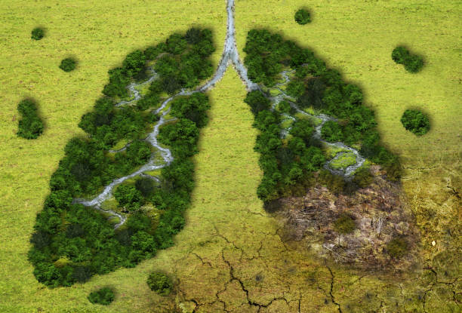 

**Get Kids into Survey**

**Our Environmental Footprint**

**It is not in the stars to hold our destiny but in ourselves**.

*William Shakespeare*

While adults may think of themselves as the custodians of **groundwater**, it is **children** who are the true guardians of water. They are the ones who will take action for the conservation of groundwater in the future! Perhaps our greatest responsibility as adults is to inspire an interest in groundwater in children and adolescents. This is challenging because groundwater is still far from being understood by everyone (apart from experts), perhaps because it is an “invisible” resource or perhaps because we’re using outdated teaching methods, **but it is necessary to make this natural resource visible.** Bringing groundwater issues to children is not a simple task, but it can be achieved with creativity and persistence. The following tips can assist in teaching children about groundwater.

* **Watching educational animated videos with your children**

They are excellent ways to spark imagination, as well as create awareness of issues relevant to the planet. It can start in childhood! For example, The Groundwater Project in partnership with [Sustainable Water Institute](http://www.aguasustentavel.org.br/) has a social media program called “Ask Professor Água” that answers questions about groundwater asked by children from around the world! Digital media has enormous power and we can use it to promote information about groundwater for children. Perhaps it’s a challenge and a wakeup call for us to start our own social media program in our vernacular languages.

* **Reading books that talk about groundwater**

Encourage kids to have contact with these types of books. Even with limited understanding, children can acquire an essential habit for their development. You can download Wally & Deanna’s Groundwater Adventure to the Saturated zone at this link: <https://gw-project.org/books/wally-and-deannas-groundwater-adventure-to-the-saturated-zone/>.

* **Participate in outdoor educational activities**

Take time to explain where spring water comes from, describe how a well works, explain how littering can affect groundwater, and more. All of this can help children understand the impact of their actions and create a sense of responsibility.

* **Create fun artwork**

Kids love colors, creativity and artwork. Create simple but informative ground water models for them to use as material. Below are a few examples!

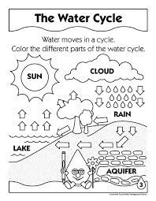

**Write a simple story about the picture below**